The angles that we need to find for this lab are

* $θ_{E}:$ the angle of the equiblerant force. We measured this one on the force table
* $θ_{R experimental}$: this is 180° different from $θ_{E}$ AND less than 360°
* $θ_{R calc}$: We find this by using the arctangent function on the components of the resultant vector in our table.
* The angle at which to draw the resultant vector on the lower set of axes. The steps for finding this are below.

1. we draw $\vec{F_{1}}$ to scale on the axes given.
2. We draw $\vec{F_{2}}$ to scale with the end of $\vec{F_{2}}$’s tail beginning at the tip of $\vec{F_{1}}$
   1. To find the angle that we should draw $\vec{F_{2}}$ at we consider the following:

Using the first portion of #3 to illustrate my process:

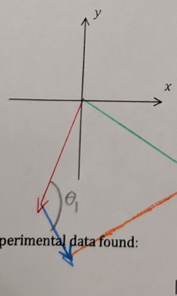 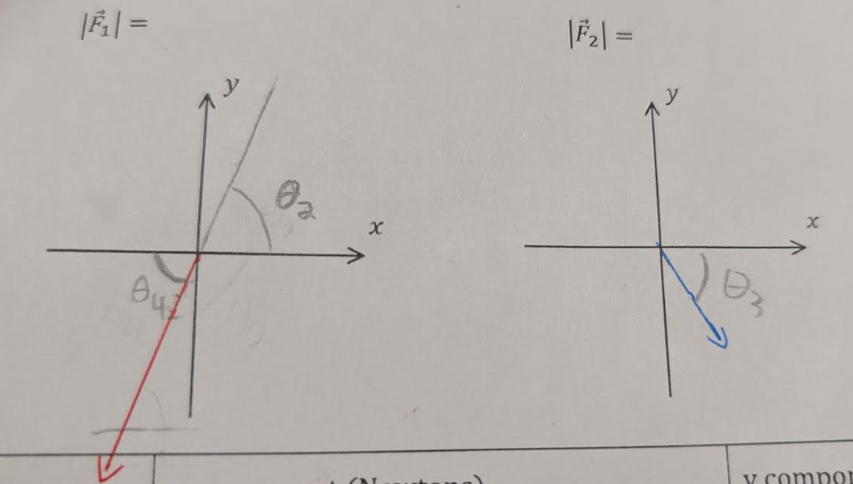

We know that:

* $θ_{1}$ is the angle that we need to find.
$θ_{1}=θ_{2}+θ_{3}$

$θ_{3}=360°-\left[the angle of \vec{F_{2}}\right],$

* $θ_{2}=θ_{4}$ because they are opposite angles (this is a rule of geometry)
* 1. We perform the following math steps based on the above givens:
 $$θ_{1}=θ_{2}+θ_{3}$$

 $$∵of points 3 \& 4 we get$$

$$θ_{1}=θ_{4}+\left(360°-\left[angle of \vec{F_{2}}\right]\right)$$

$$∵of point 5 we get$$

$$θ_{1}=\left(\left[the angle of \vec{F_{1}}\right]-180°\right)+\left(360°-\left[angle of \vec{F_{2}}\right]\right)$$

2. We can then place our protractor so that the zero degree line is on top of the vector that represents $\vec{F_{1}}$ and measure out $θ_{1}$